# **A PROJECT ON**

**Bankify**

SUBMITTED IN

PARTIAL FULFILLMENT OF THE REQUIREMENT

FOR THE COURSE OF DIPLOMA IN ADVANCED COMPUTING FROM CDAC



#### SUNBEAM INSTITUTE OF INFORMATION TECHNOLOGY

Hinjawadi

**SUBMITTED BY:**

Yash Swaroop

**UNDER THE GUIDENCE OF:**

Pooja Jaiswal

Faculty Member

Sunbeam Institute of Information Technology, Pune

**CERTIFICATE**

This is to certify that the project work under the title ‘Bankify -An E-Banking App ’ is done by Yash Swaroop in partial fulfillment of the requirement for award of Diploma in Advanced Computing Course.

**Mr. Yogesh Kolhe**

**Course Coordinator**

Project Guide

Pooja Jaiswal

ACKNOWLEDGEMENT

A project usually falls short of its expectation unless aided and guided by the right persons at the right time. We avail this opportunity to express our deep sense of gratitude towards Mr. Nitin Kudale (Center Coordinator, SIIT, Pune) and Mr. Yogesh Kolhe (Course Coordinator, SIIT ,Pune) .

We are deeply indebted and grateful to them for their guidance, encouragement and deep concern for our project. Without their critical evaluation and suggestions at every stage of the project, this project could never have reached its present form.

Last but not the least we thank the entire faculty and the staff members of Sunbeam Institute of Information Technology, Pune for their support.

0225 PG-DAC

SIIT Pune

Bankify-An E-Banking App

1.Introduction

The web-based **“Bankify”** project is an attempt to simulate the basic concepts of an online banking system. The system enables users to perform essential banking operations such as creating an account, logging in securely, viewing account details, checking transaction history, and applying for various banking services through a user-friendly interface.

The system provides a **Quick Access feature** that allows users to view general information about banking services without logging in. However, to perform operations like managing accounts, transferring funds, or applying for services, the user must log in to their account securely using authentication and authorization mechanisms.

The system supports three types of users: **Customers, Managers, and Admin**. Each user, upon successful login, is directed to their respective dashboard with role-based access. Customers can view their account details, check balances, perform transactions, and apply for services such as loans. Managers can oversee customer requests, manage assigned accounts, and monitor branch-level operations. The Admin has full control over the system, including managing users, assigning roles, monitoring system activity, and maintaining overall banking operations.

When a customer performs a transaction or applies for a service, the system validates the input data, ensures security checks, and updates the banking database accordingly. All actions are logged to maintain transparency and system integrity. This ensures a secure, efficient, and reliable digital banking experience for all users of the Bankify system.

2.Requirements

* 1. Functional Requirements(Use Cases)

2.1.1Customer

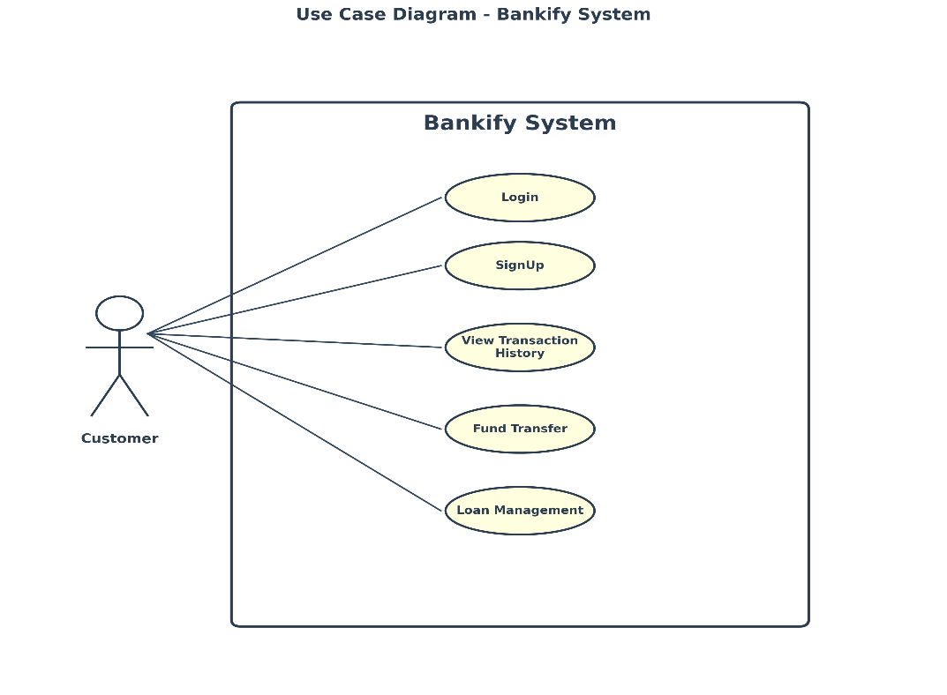

The **Bankify E-Banking System** provides a set of essential online banking functionalities specifically designed for **customers**. The **SignUp** functionality allows new customers to register by providing their personal, contact, and account-related details, after which they can securely access the system. Registered customers use the **Login** feature to authenticate themselves and enter the banking portal. Once logged in, customers can view their complete **Transaction History**, which displays all debit and credit transactions along with transaction date, amount, and status. The **Fund Transfer** functionality enables customers to securely transfer funds between their own accounts or to other bank accounts, ensuring fast and reliable monetary transactions. Additionally, the **Loan Management** feature allows customers to apply for loans, view approved loan details, check outstanding balances, and monitor repayment schedules. Together, these functionalities provide customers with a secure, convenient, and efficient digital banking experience.

2.1.2Manager

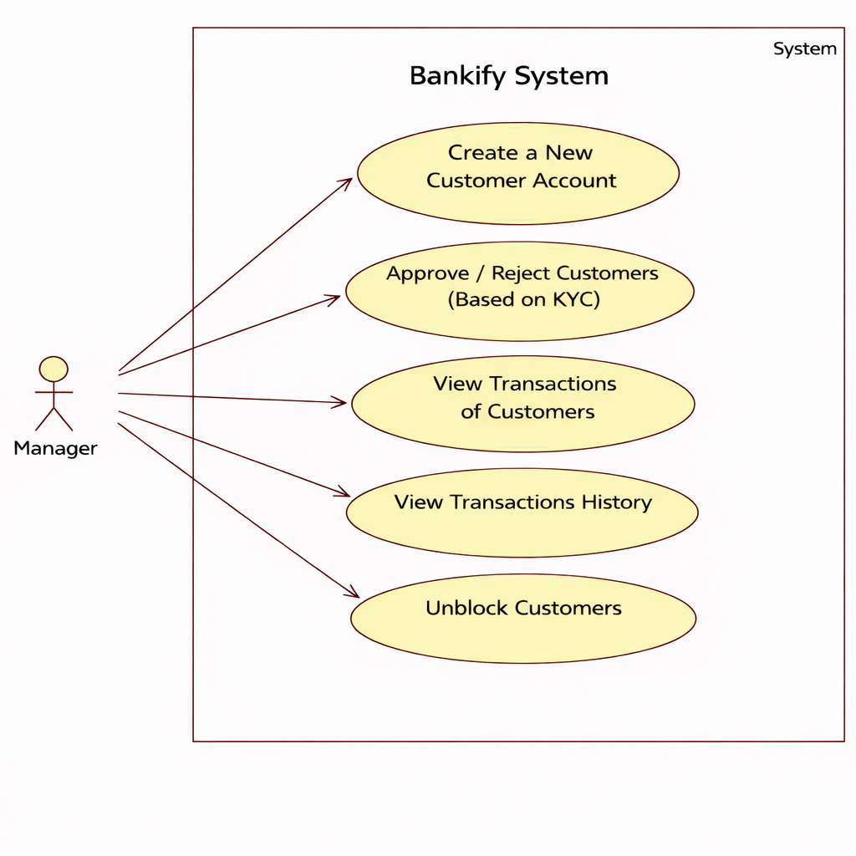

In the **Bankify E-Banking System**, the **Manager** plays a crucial role in controlling and monitoring customer accounts and ensuring regulatory compliance. The manager has the authority to **create new customer accounts** after verifying the initial application details submitted by customers. Based on the completion and verification of **Know Your Customer (KYC)** documents, the manager can **approve or reject customer accounts**, ensuring that only verified customers are allowed to access banking services. The system also allows the manager to **view customer transaction details**, enabling effective monitoring of financial activities and detection of suspicious or fraudulent transactions. Additionally, the manager can **unblock or reactivate rejected customers** once the required KYC documents are completed and verified. These functionalities ensure secure operations, regulatory compliance, and efficient customer management within the Bankify system.

2.1.3AdminTop of Form

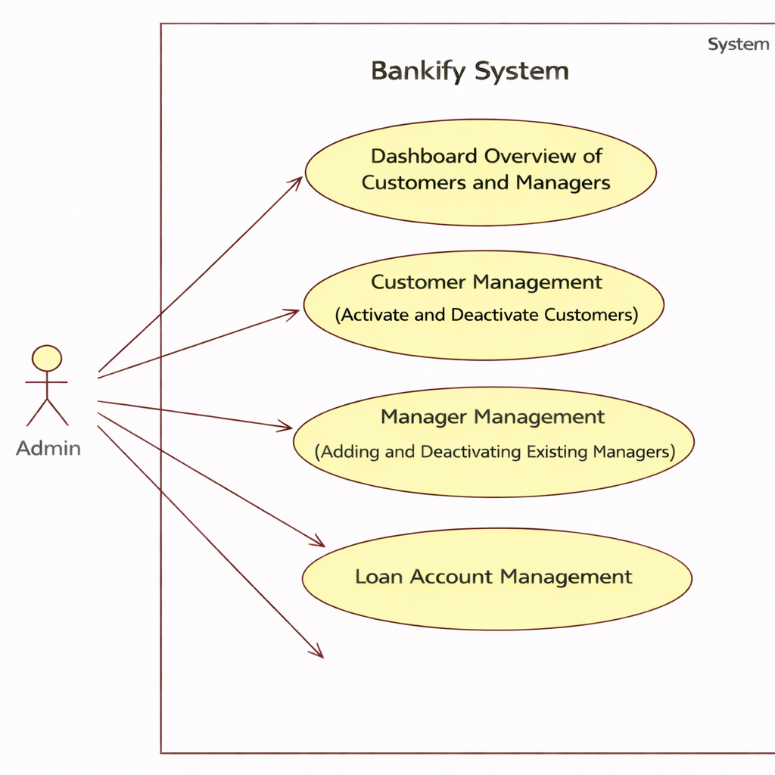

In the **Bankify E-Banking System**, the **Admin** has complete control over system operations and user management. The admin can access a **dashboard overview** that displays comprehensive information about all registered **customers and managers**, including their status and activity summaries. Through **Customer Management**, the admin can **activate or deactivate customer accounts**, ensuring control over access to banking services when required. The system also provides **Manager Management**, allowing the admin to **add new managers** and **deactivate existing managers** based on organizational needs. Additionally, the admin is responsible for **Loan Account Management**, which includes monitoring loan accounts, managing loan records, and overseeing the overall loan lifecycle within the system. These functionalities enable the admin to maintain security, operational efficiency, and smooth governance of the Bankify platform.

2.2Non Functional Requirementsm of Form

**Performance**

**• Number of Concurrent Users**

The **Bankify E-Banking System** shall be capable of handling **at least 1000 concurrent users and transactions per second** without performance degradation. The system is designed to support simultaneous customer activities such as login, fund transfers, transaction history retrieval, and loan-related operations.

**• Online Banking Transactions**

The system is designed to ensure **high availability and fault tolerance** during online banking operations. Even in the event of a **temporary server failure or network disruption**, Bankify ensures data consistency and transaction safety using reliable backend technologies and transaction management mechanisms. Any interrupted banking operation can be safely resumed once the system connection is restored.

**2.2.3 Constraints**

The **Bankify E-Banking System** must support **a minimum of 1000 transactions or service requests per second**, ensuring scalability and responsiveness during peak usage hours.

**2.2.4 Other Requirements**

**▪ Hardware Interfaces**

The Bankify system is expected to function on hardware configurations equivalent to or higher than:

* Intel Core i3 Processor or above
* 4 GB RAM (minimum)
* 50 GB Hard Disk Space

**▪ Software Interfaces**

The Bankify E-Banking System shall operate on modern operating systems and software environments, including:

* Operating Systems: Windows 10/11, Linux
* Database: MySQL / PostgreSQL
* Server: Apache Tomcat
* Backend Framework: Spring Boot
* Frontend: ReactJS
* Web Browsers: Google Chrome, Mozilla Firefox, Microsoft Edge

3. Design

Database-Design

Table1-Users

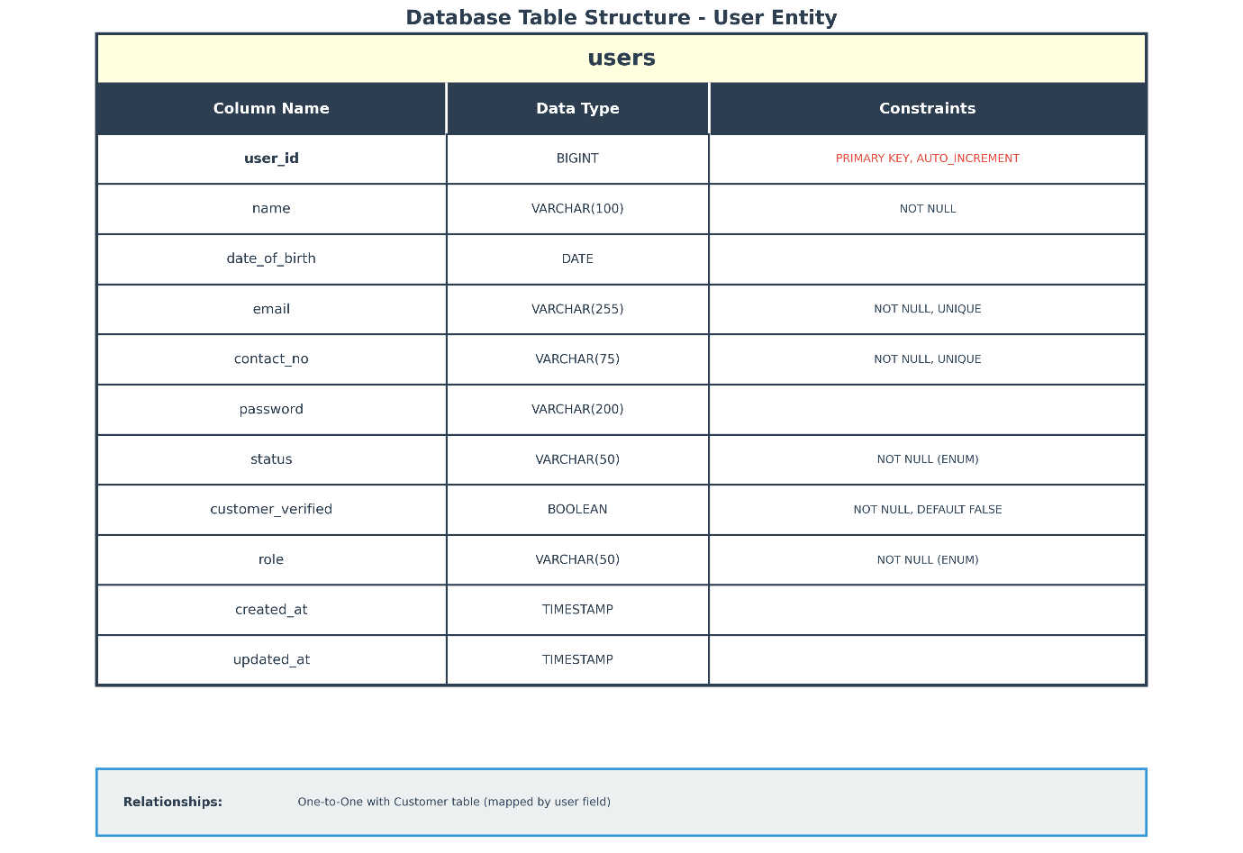

Table-2 Customer

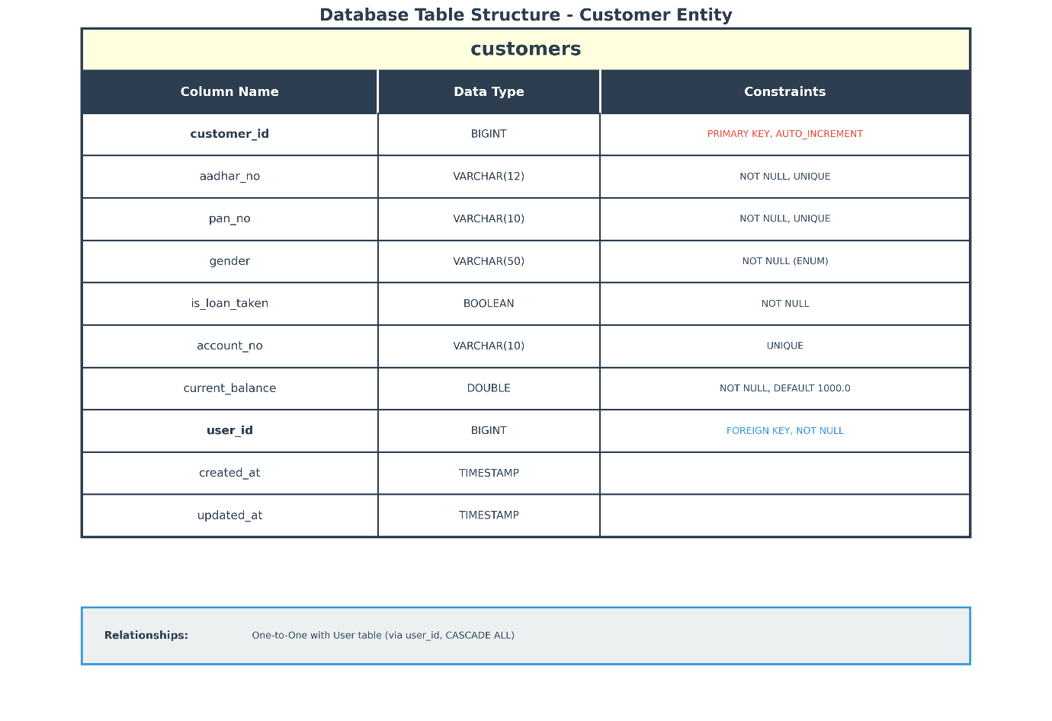

Table-3 Loans

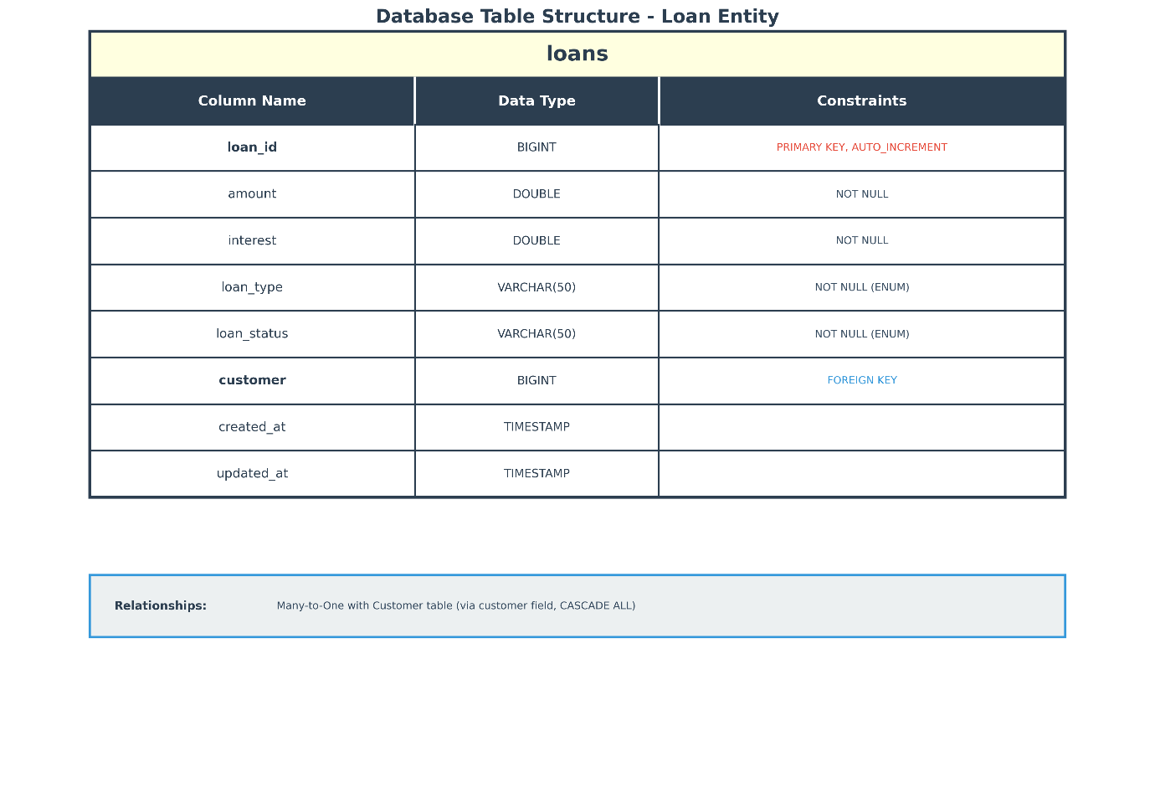

Table-4 Loan-Details

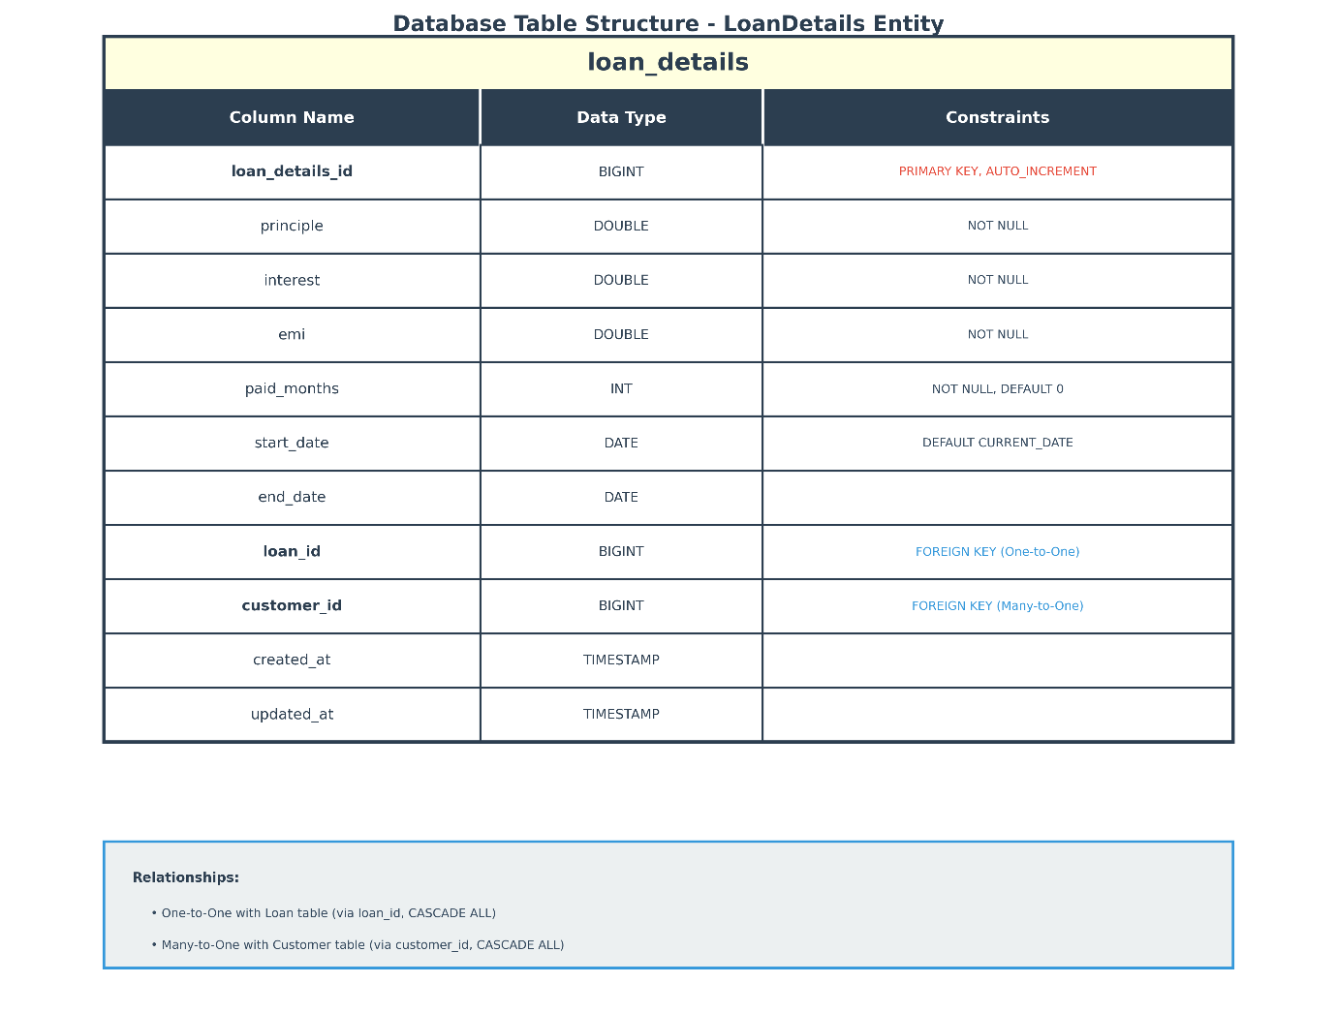

Table-5 Transactions

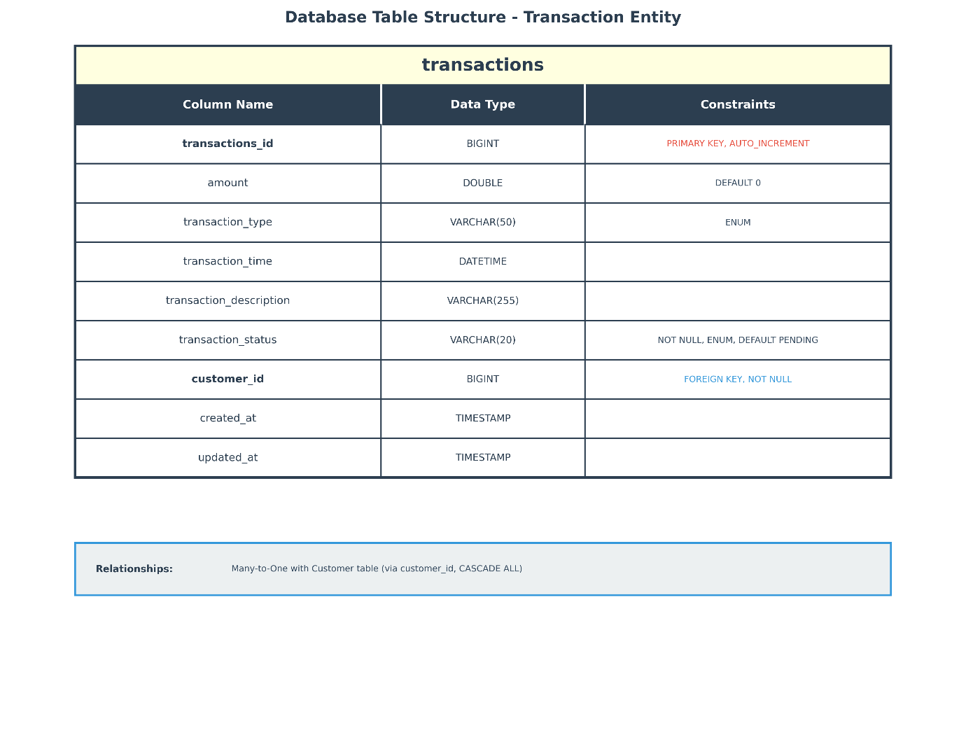

Table-6 Loan OTP

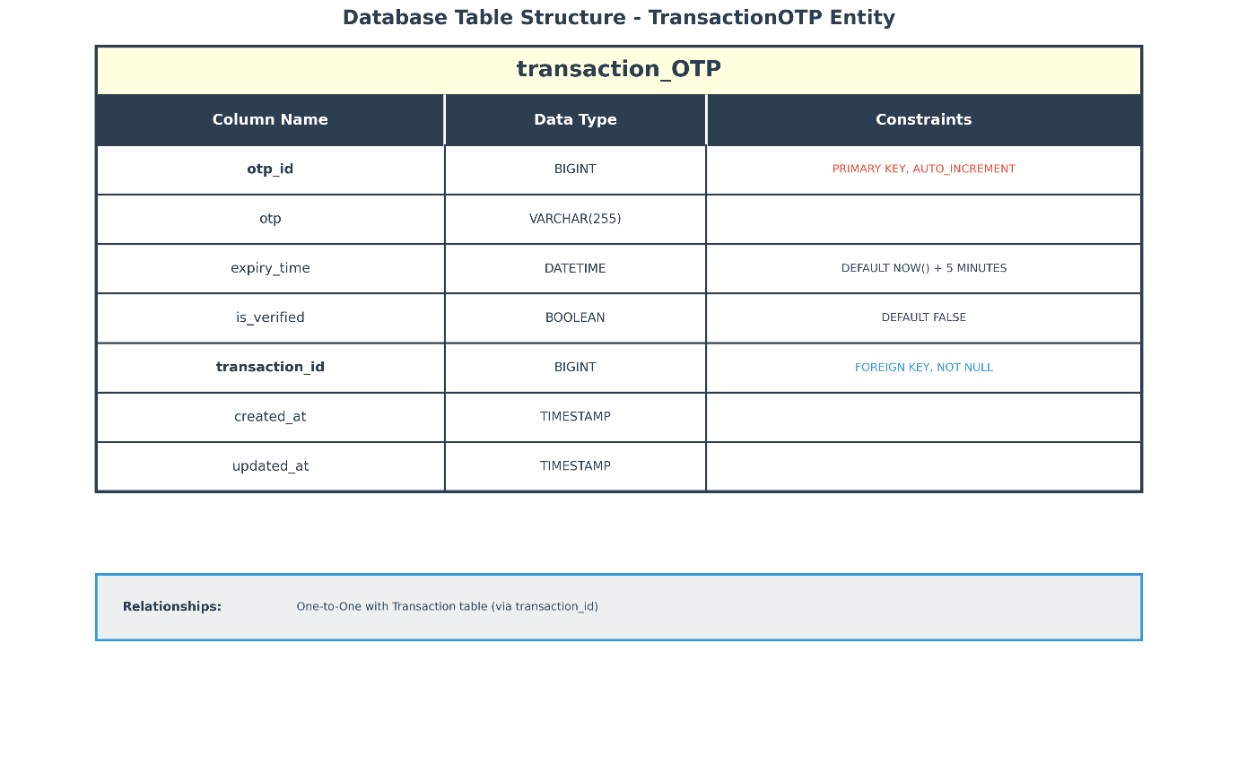

Table-7 Address

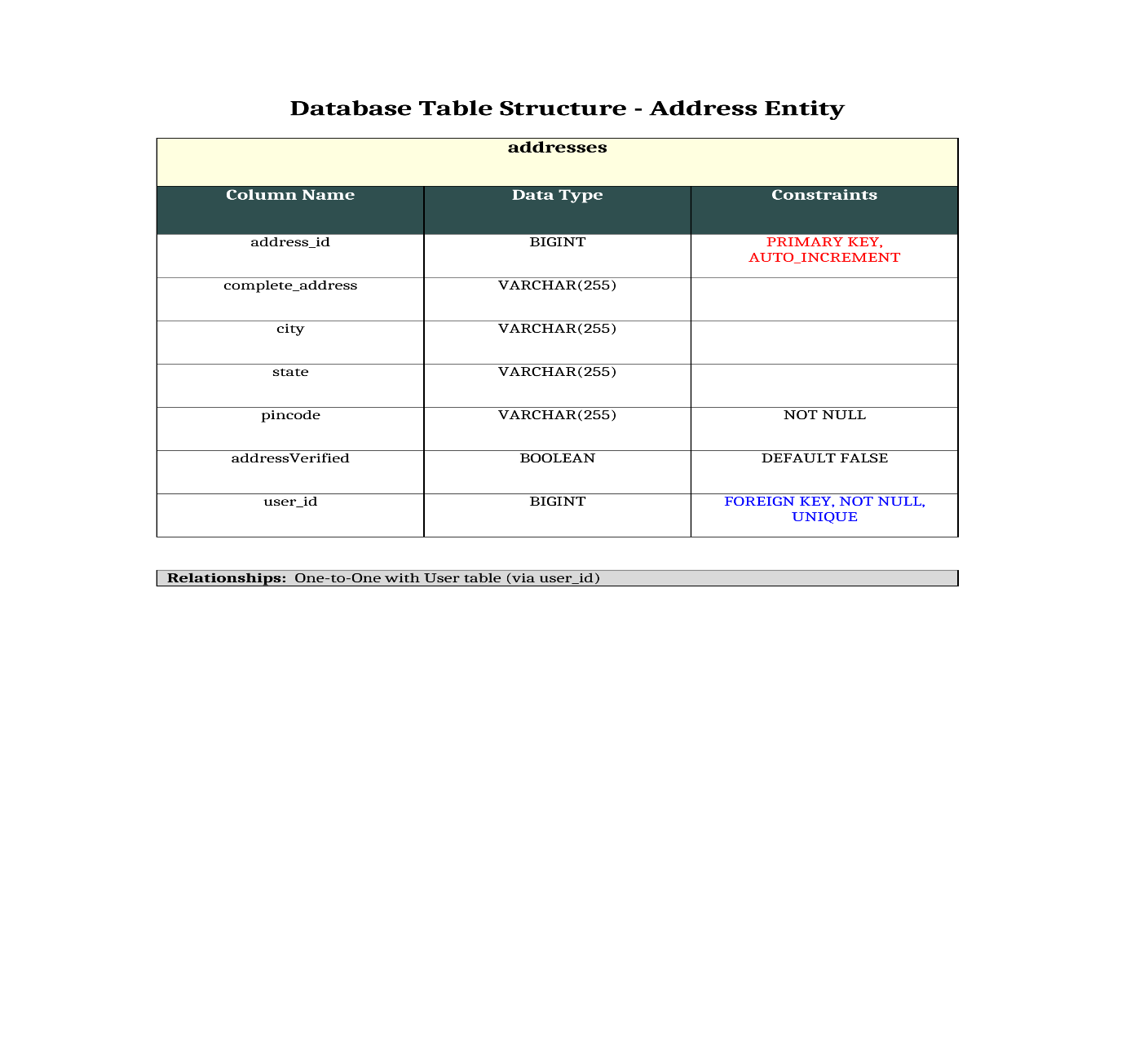

Table -8 Transaction-History

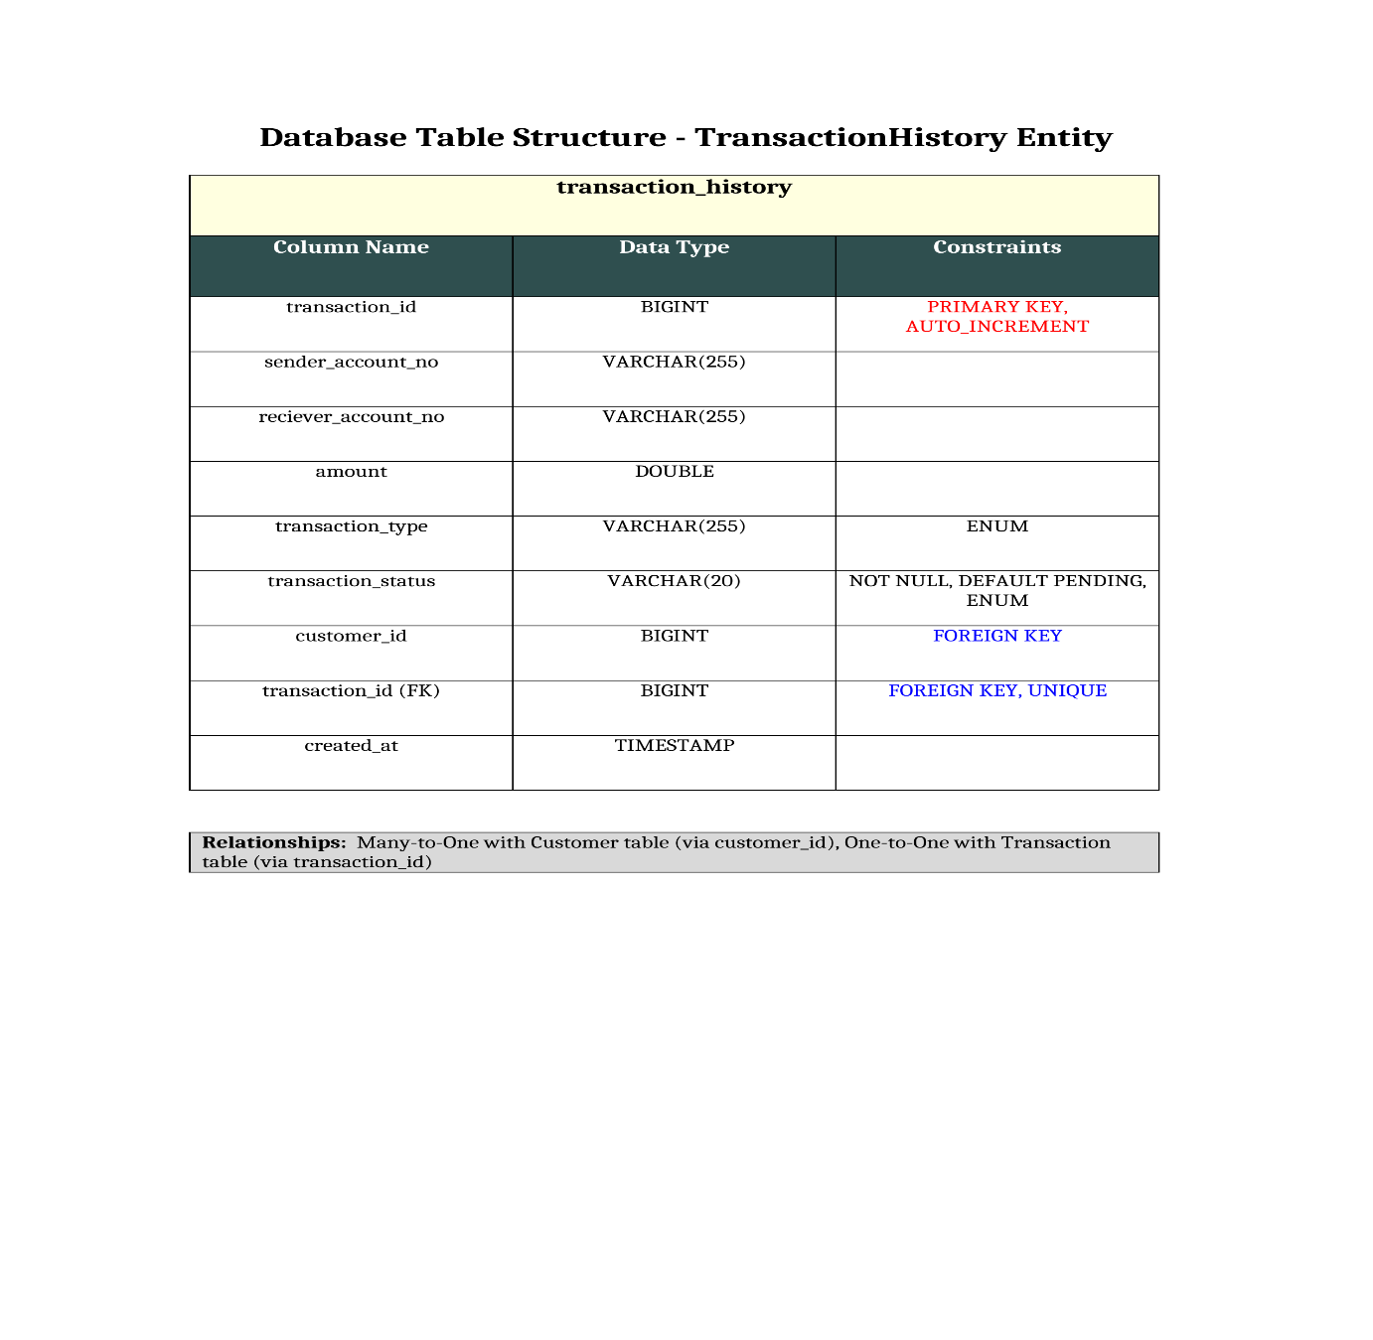

**4. CODING STANDARDS IMPLEMENTED**

### Naming and Capitalization

Below summarizes the naming recommendations for identifiers in Pascal casing is used mainly (i.e. capitalize first letter of each word) with camel casing (capitalize each word except for the first one) being used in certain circumstances.

|  |  |  |  |
| --- | --- | --- | --- |
| **Identifier** | **Case** | **Examples** | **Additional Notes** |
| Class | Pascal | Person, BankVault, SMSMessage, Dept | Class names should be based on "objects" or "real things" and should generally be **nouns**. |
| Method | Camel | getDetails, updateStore | Methods should use **verbs** or verb phrases. |
| Parameter | **snake_case** | aadhar_number, pan_no | Use descriptive parameter names. Parameter names should be descriptive enough that the name of the parameter and its type can be used to determine its meaning in most scenarios. |
| Interface | Pascal | Disposable | Do not use the ‘_’ sign |
| Exception Class | Pascal with "Exception" suffix | WebException, |  |

### Comments

* Comment each type, each non-public type member, and each region declaration.
* Use end-line comments only on variable declaration lines. End-line comments are comments that follow code on a single line.
* Separate comments from comment delimiters (apostrophe) or // with one space.
* Begin the comment text with an uppercase letter.
* End the comment with a period.

|  |
| --- |
| **5. TEST REPORT** |
| **GENERAL TESTING** |
| |  |  |  |  |  | | --- | --- | --- | --- | --- | | **SR-NO** | **TEST CASE** | **EXPECTED RESULT** | **ACTUAL RESULT** | **ERROR MESSAGE** | | 1 | Customer SignUp | Customer account should be created successfully | OK | Nothing | | 2 | Customer Login | Customer should login successfully | OK | Invalid credentials (for wrong input) | | 3 | View Dashboard | Customer dashboard should be displayed | OK | Nothing | | 4 | View Transaction History | All previous transactions should be displayed | OK | Nothing | | 5 | Fund Transfer | Amount should be transferred successfully | OK | Insufficient balance (if applicable) | | 6 | Session Validation | System should verify logged-in customer | OK | Nothing | | 7 | Loan Application | Loan request should be submitted | OK | Nothing | | 8 | Loan Status Check | Loan details should be displayed correctly | OK | Nothing | | 9 | Manager KYC Approval | Customer should be approved or rejected based on KYC | OK | Nothing | | 10 | Admin Customer Activation | Customer should be activated/deactivated | OK | Nothing | | 11 | Logout | Customer/Manager/Admin should be logged out successfully | OK | Nothing | | 12 | Manager Create Customer | Customer account should be created successfully | OK | Nothing | |

**Appendix-A**

**E-R Diagram**

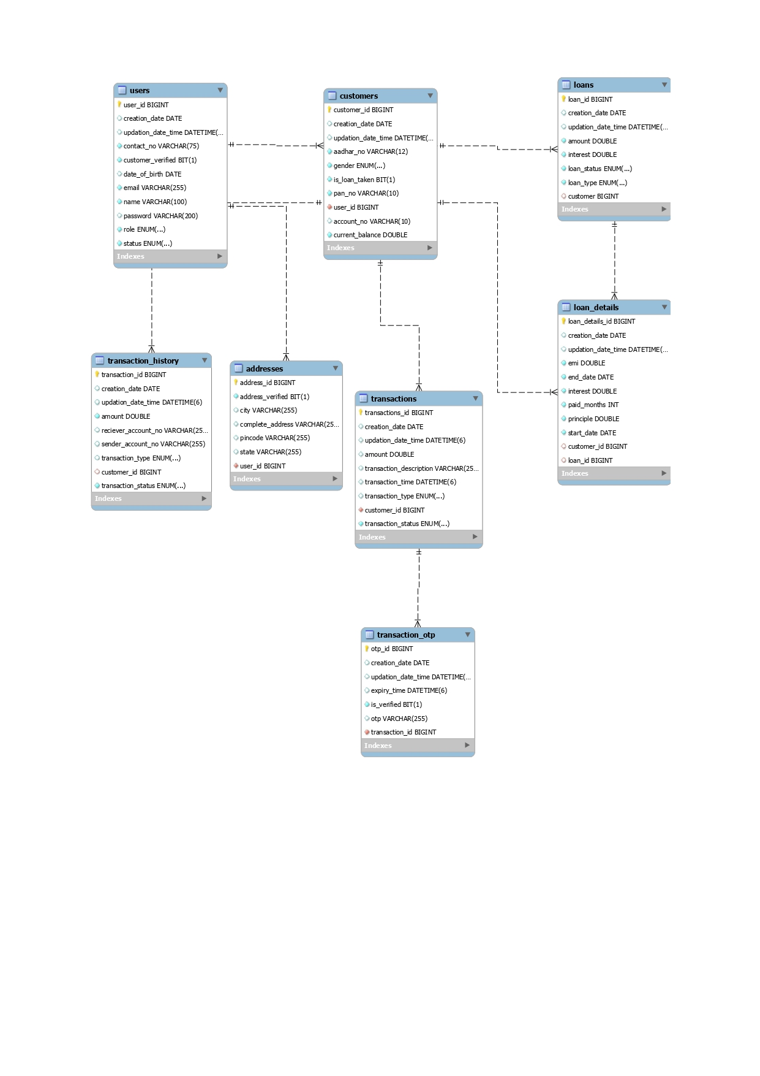

**Class Diagram**

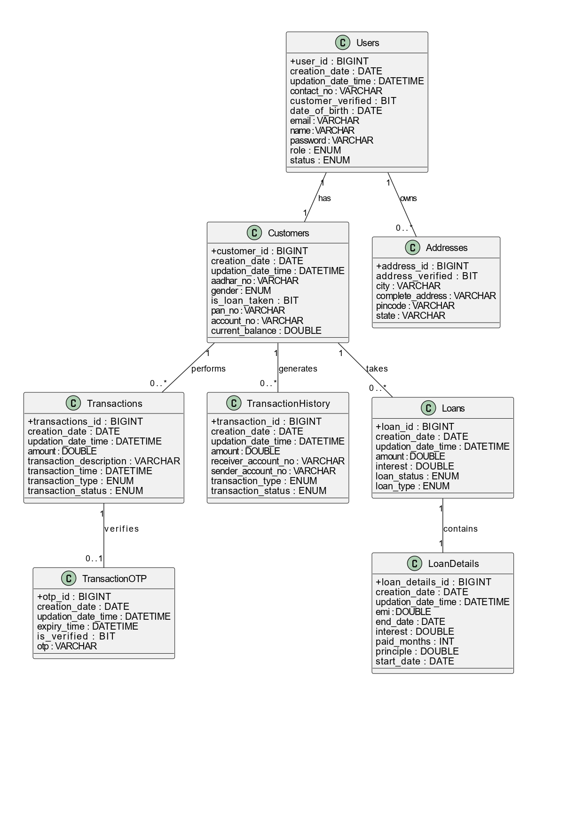

**Appendix-B(Screenshots)**

Homepage

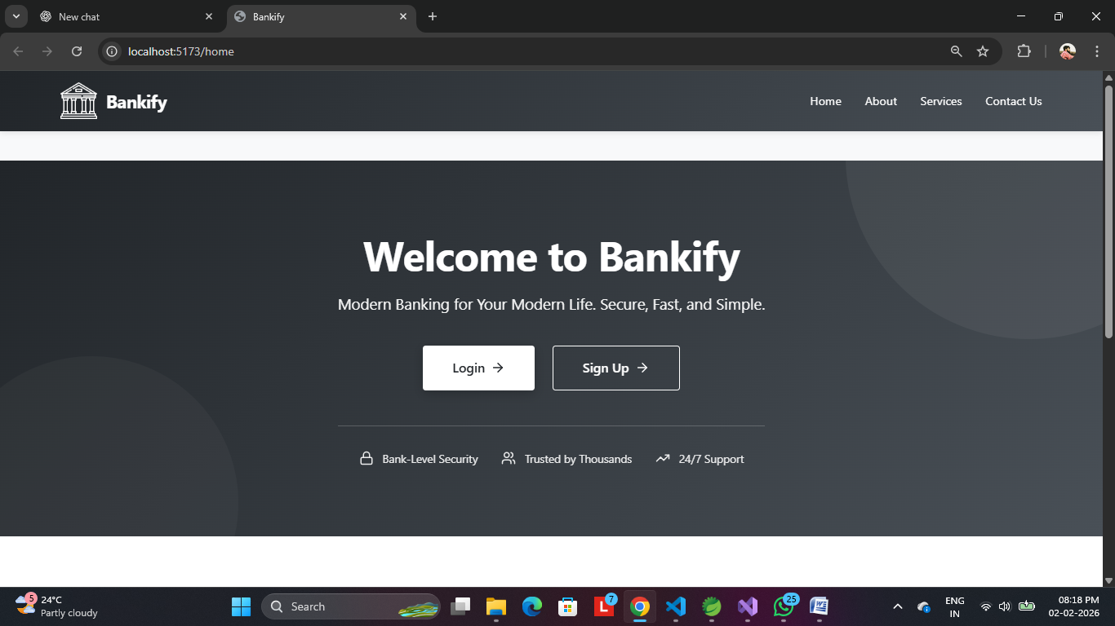

Login

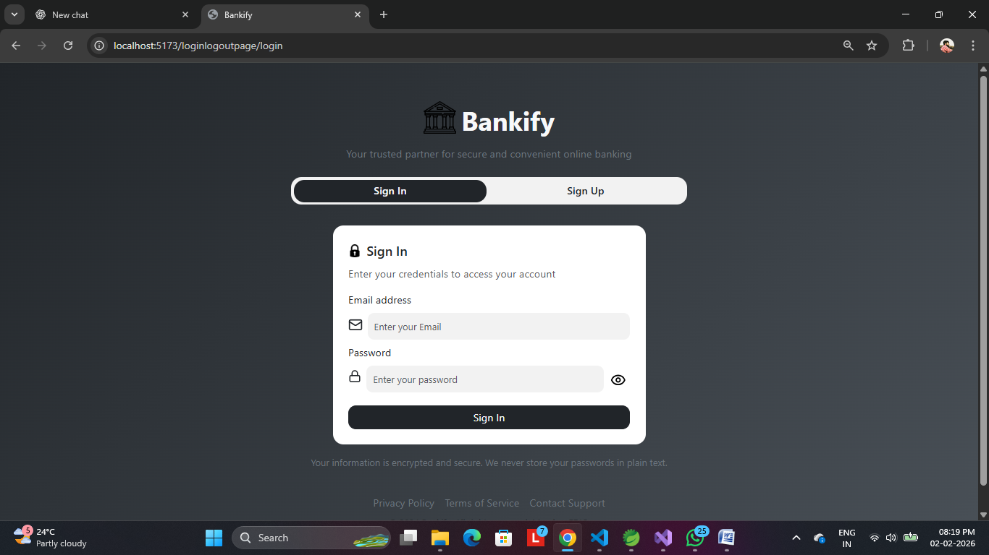

Sign Up

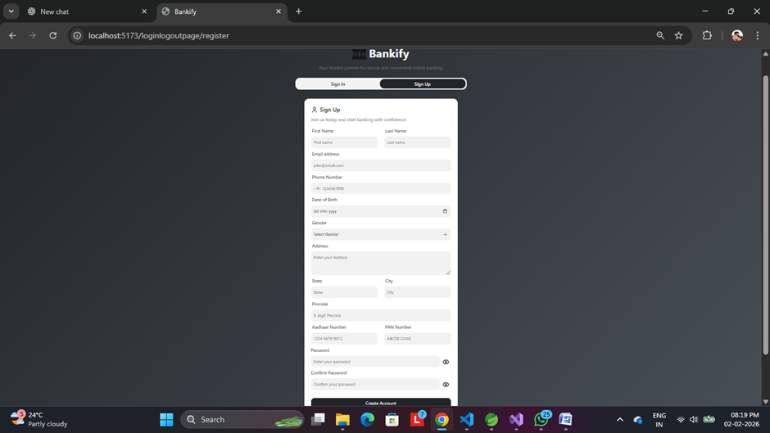

Customer Dashboard

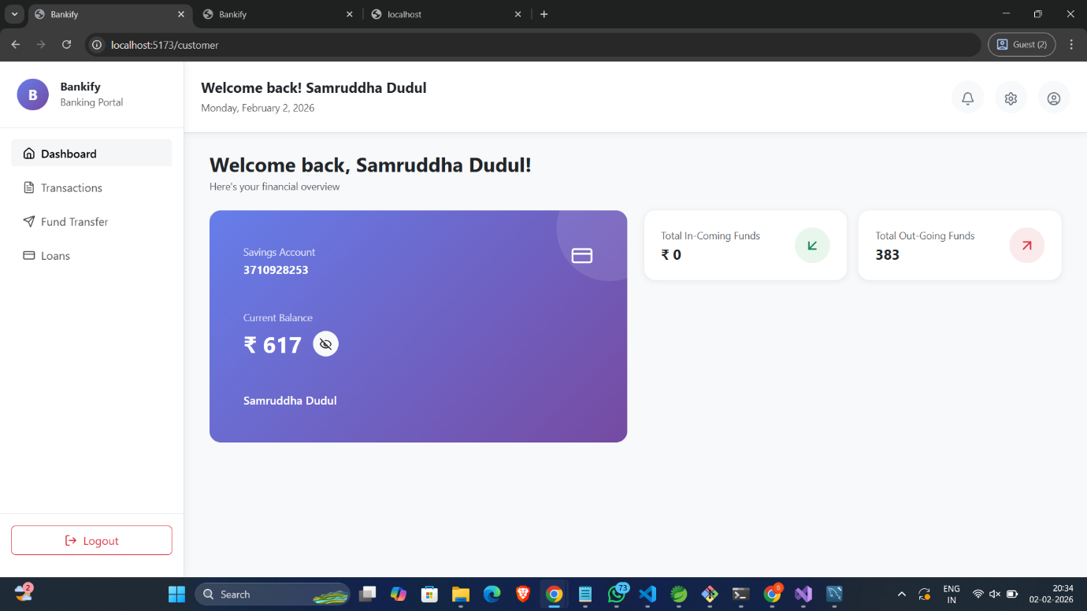

Customer Transactions

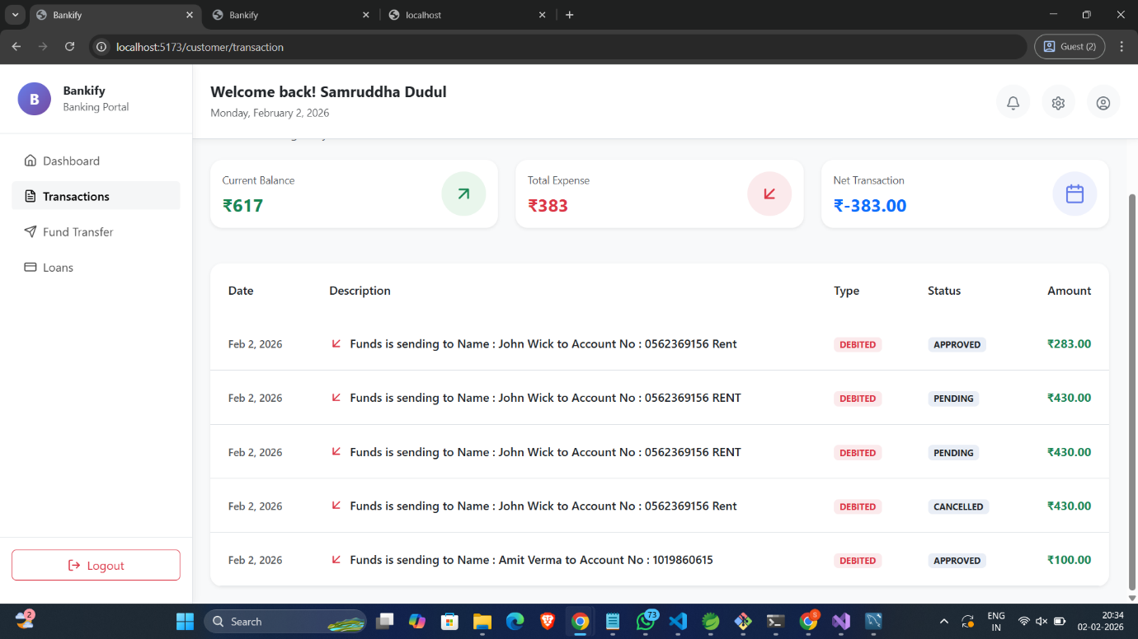

Customer Fund Transfer(New Transfer)

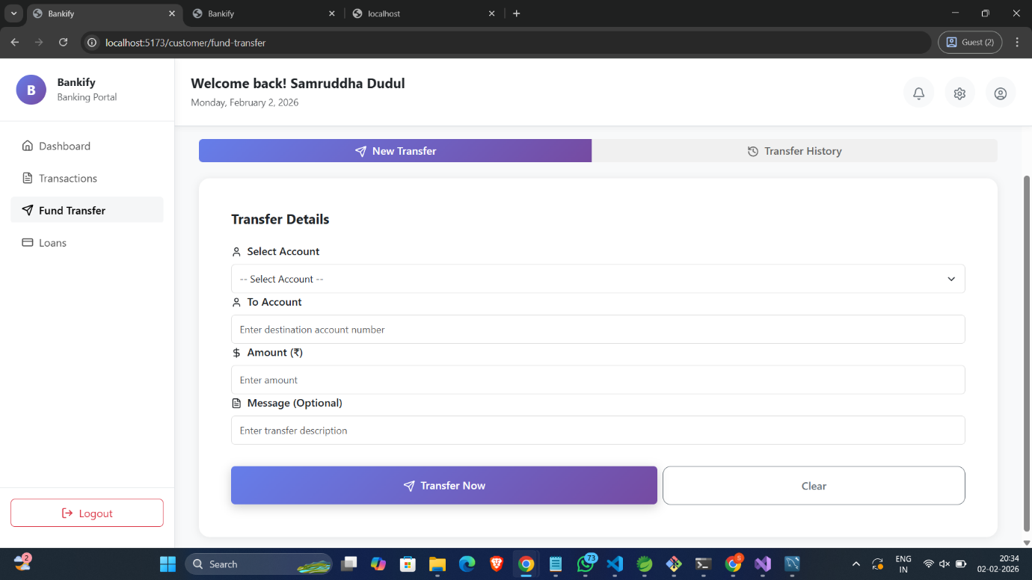

Fund Transfer(Transaction History)

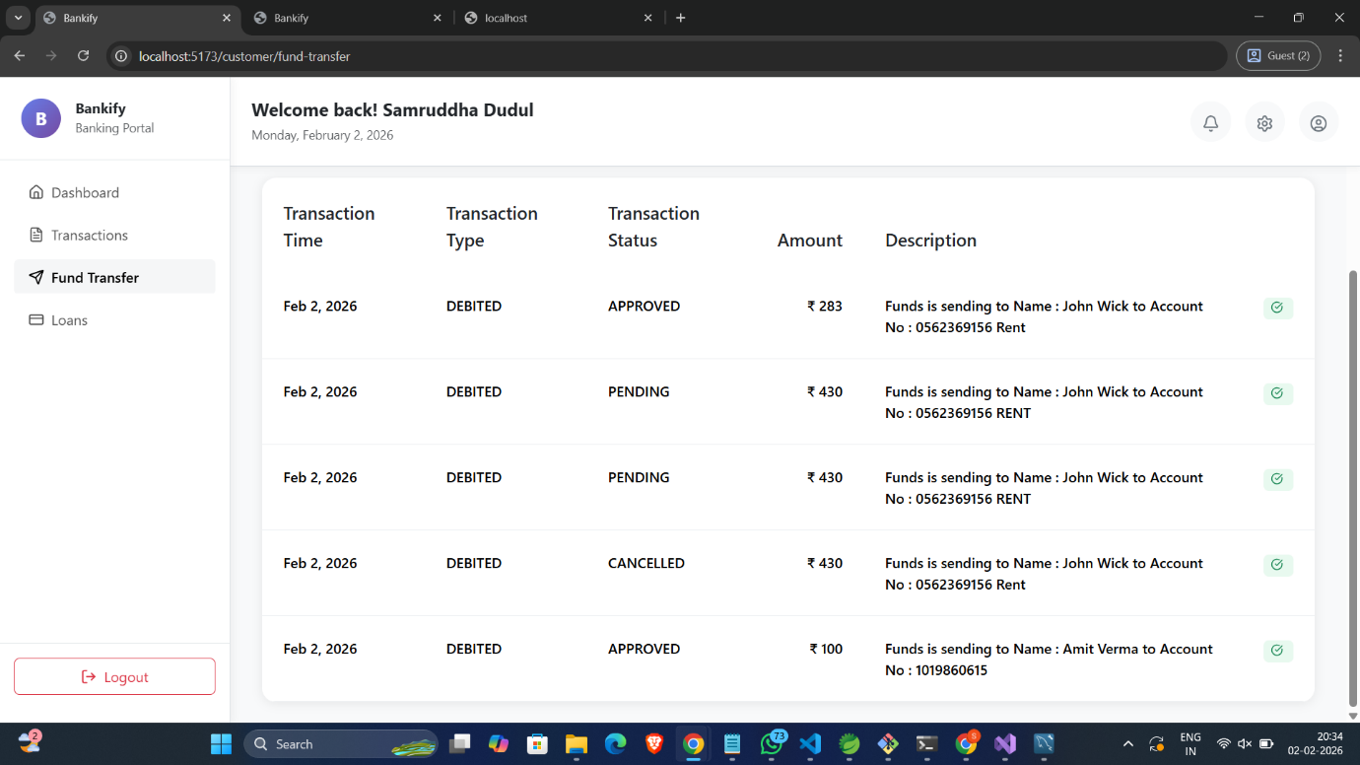

Fund Transfer (OTP)

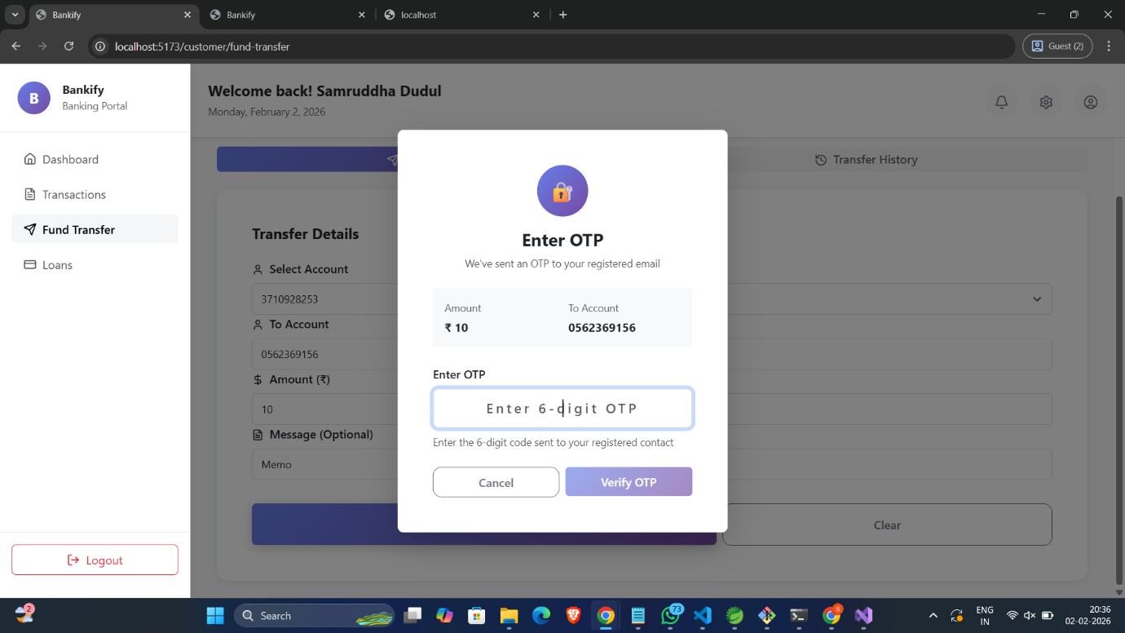

Loan Details

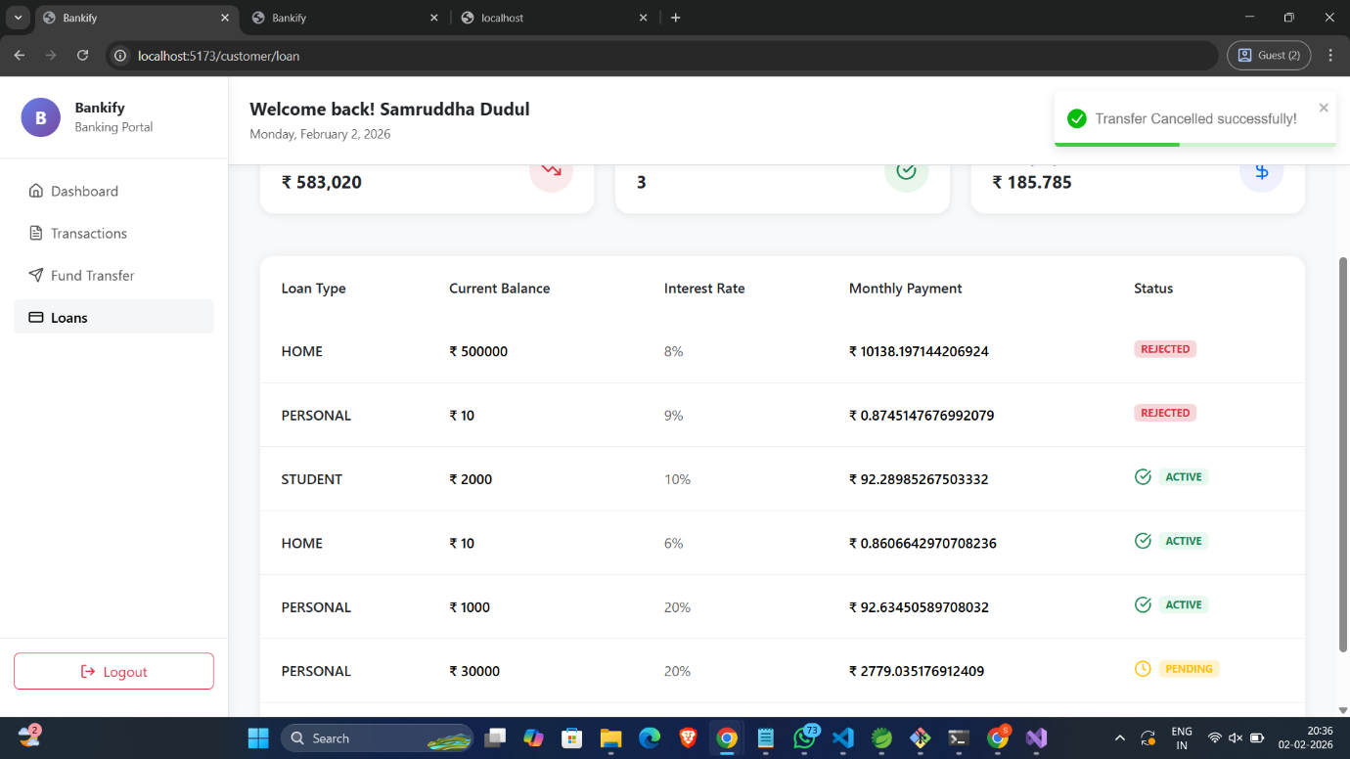

Manager Create Customer

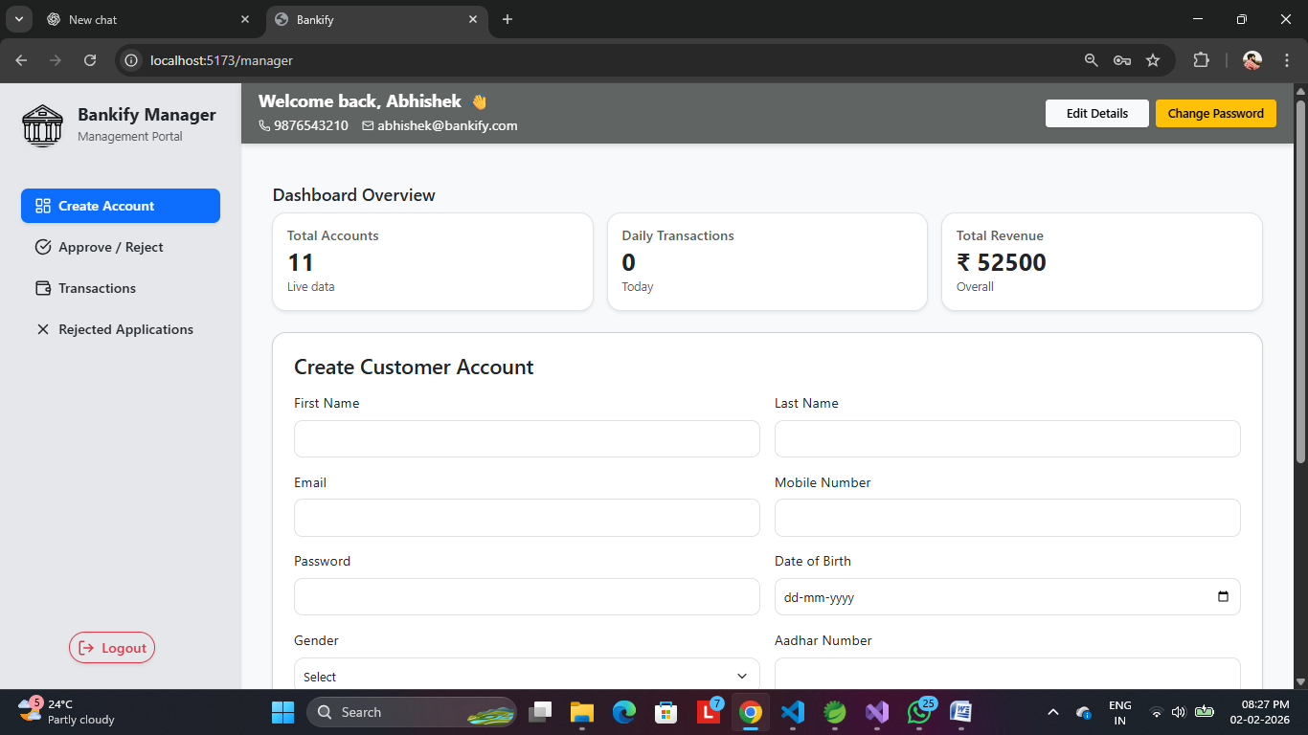

Edit Details

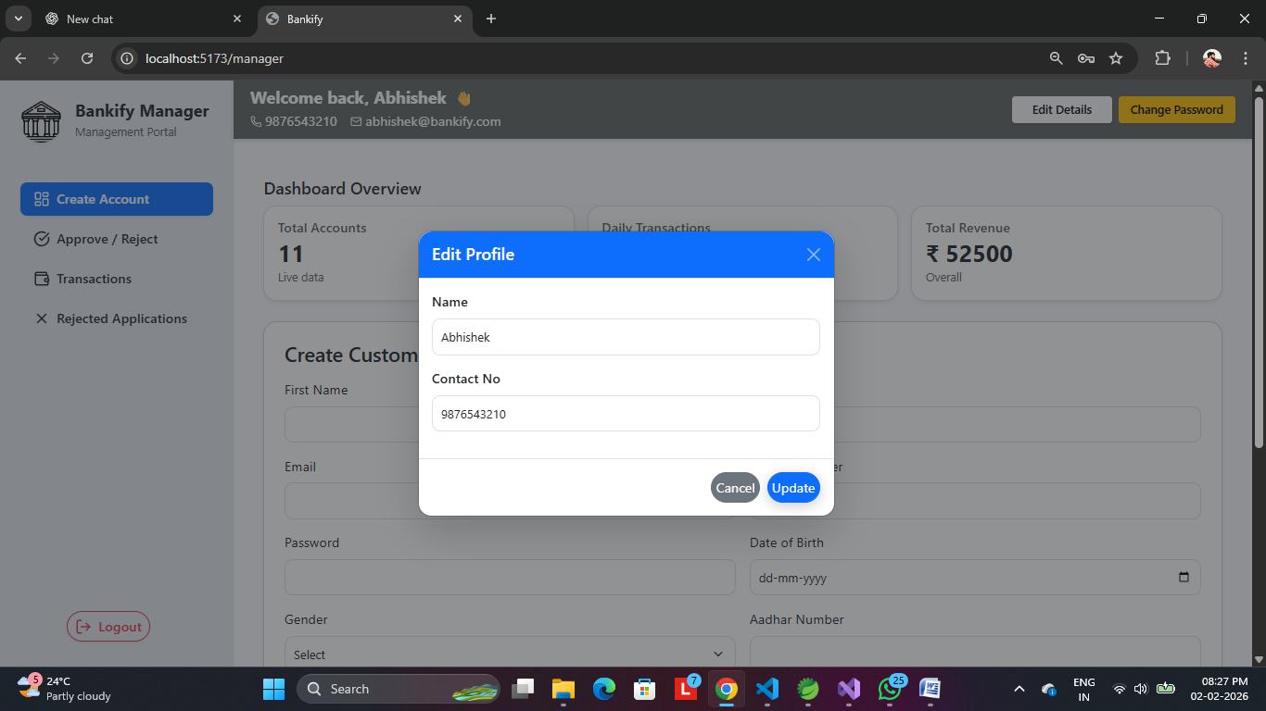

Change Password

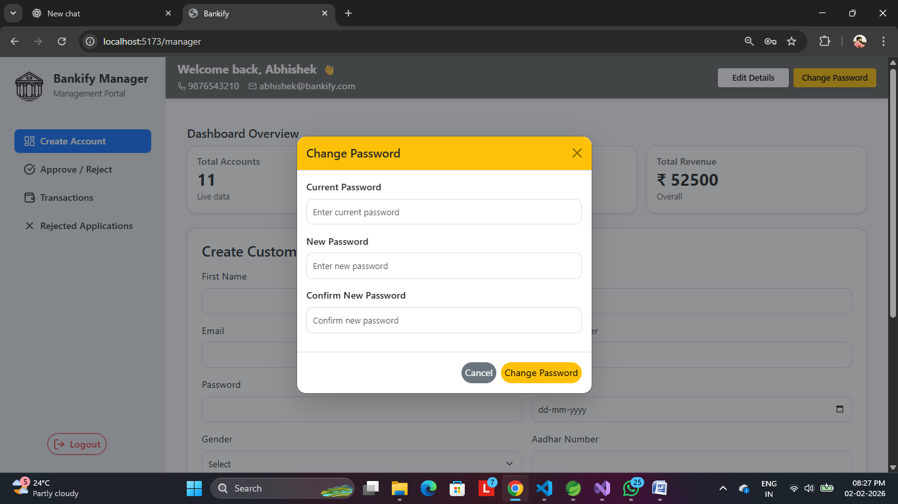

Approve/Reject

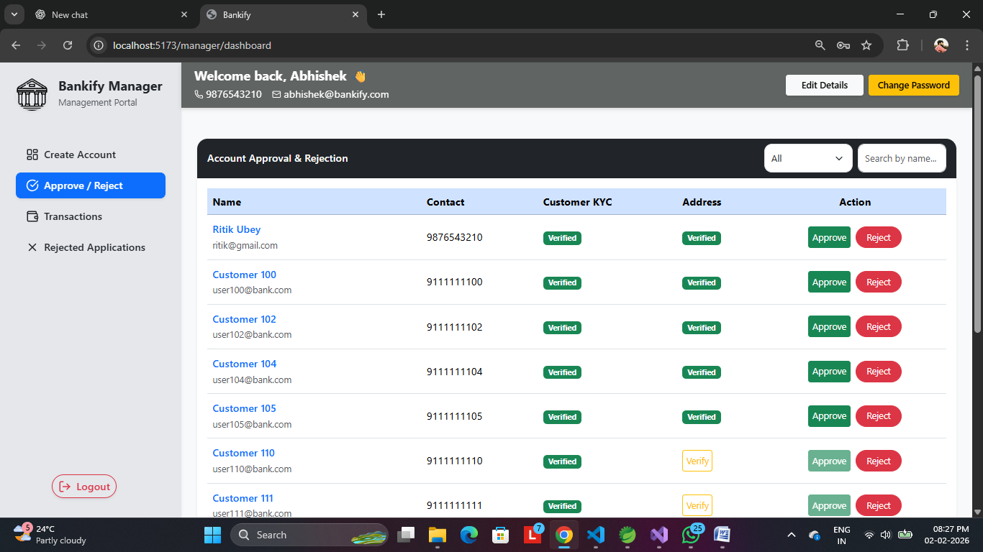

Manager Transactions

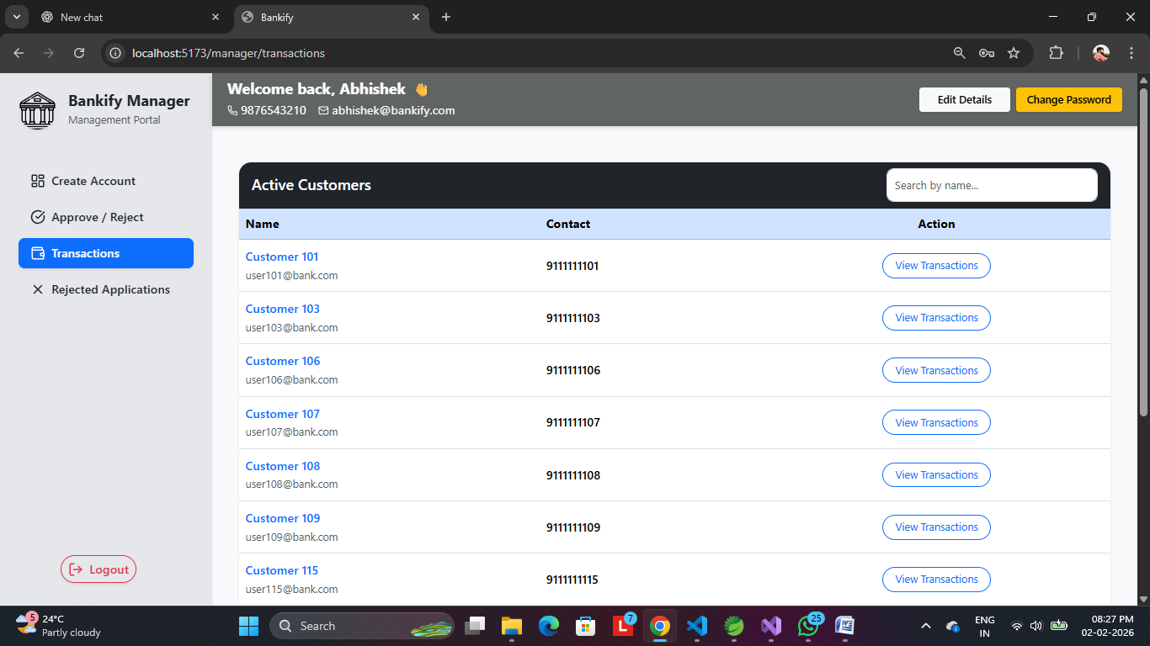

Rejected Applications

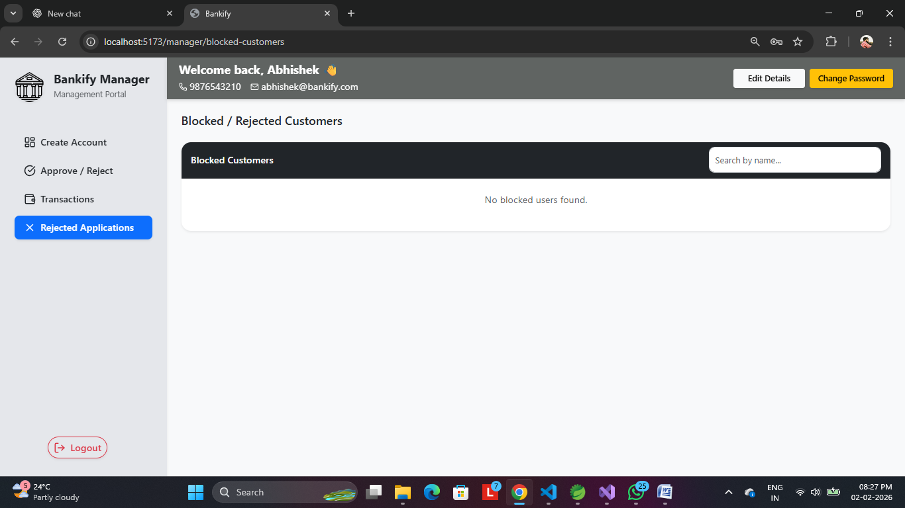

Admin Dashboard

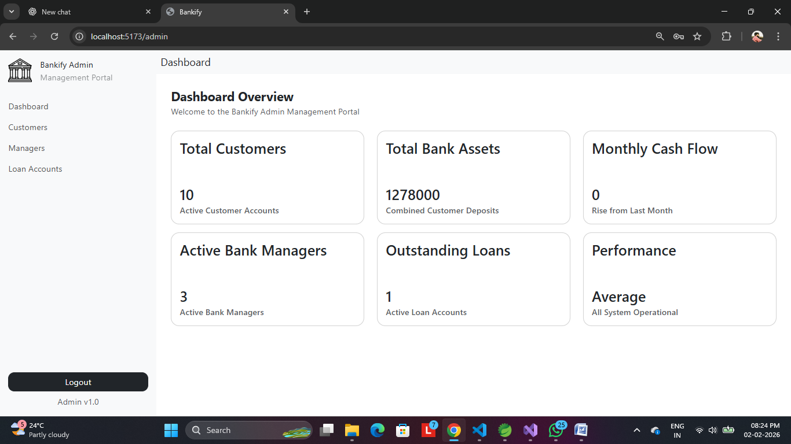

Customer_List

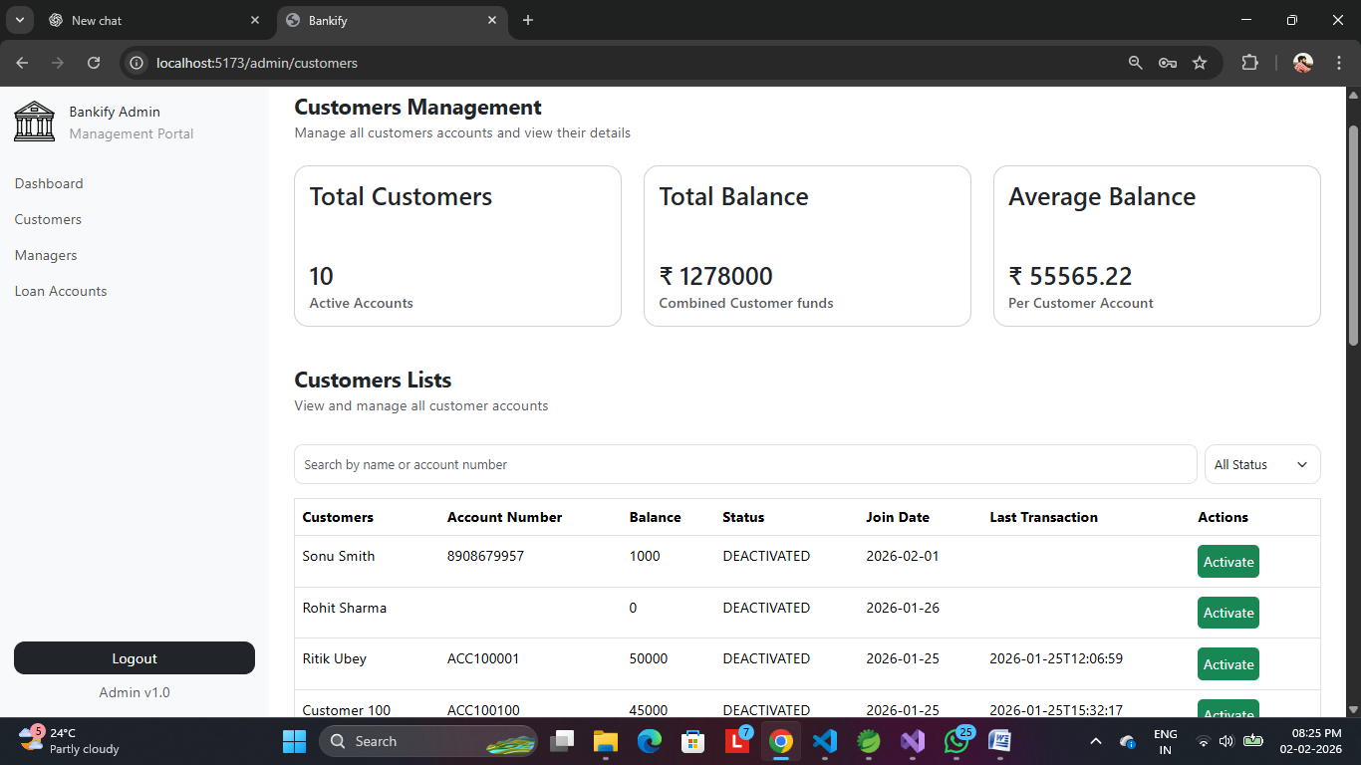

Manager List

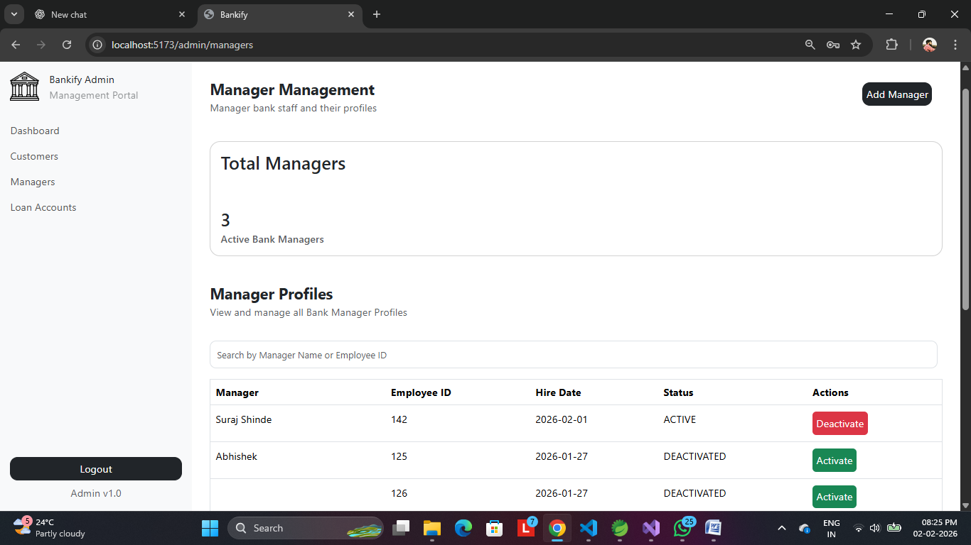

Create Manager

